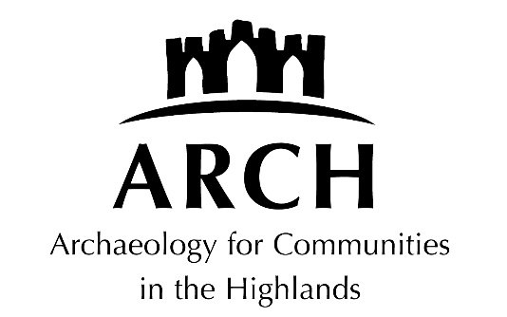

Checked and approved: July 2021, 2024

EQUAL OPPORTUNITIES POLICY

The following definitions apply to this document:

1. Board members: members appointed to ARCH board;
2. Employees/staff: paid individuals who undertake work for ARCH on behalf of the company;
3. Volunteers: unpaid individuals who help run events on the company’s behalf; and
4. Members of the public: members of the public who attend ARCH events.

Policy

Archaeology for Communities in the Highlands (ARCH) is an equal opportunities employer. We aim not to discriminate, and we welcome minority ethnic groups and disabled people.

ARCH has considered and is compliant with current guidance from the Equality and Human Rights Commission, and in particular the requirements of the Equality Act 2010.

ARCH believes that individuals are of equal worth whatever their age, sex, race, level of disability, potential for pregnancy, marital status, sexual orientation, gender reassignment, or religious practice and background.

ARCH is fully committed to the active promotion of equal opportunity in its employment practices, in the work it undertakes, and in the provision of all its services.

In its capacity as an employer, and as an organisation concerned with providing opportunities for people to improve their knowledge in, and participate in the recording of, the rich archaeological heritage of their communities, ARCH is determined to make all efforts to prevent discrimination against any of its existing staff, potential staff or users of its services on grounds of their age, sex, race, level of disability, potential for pregnancy, marital status, sexual orientation, gender reassignment, or religious practice and background. ARCH is opposed to discriminatory attitudes, behaviour and practices on any of these grounds and is committed to translating this principle into all aspects of its work.

Statement of Intent and Implementation Programme

ARCH recognises that policies will not in themselves provide equality of opportunity and acknowledges that specific positive action is needed. As part of a planned strategy, ARCH is or will be introducing the following measures to combat direct and indirect discrimination in its employment practices, in the work it undertakes, and in the services it provides:

- promoting a greater awareness within the organisation of the needs of those experiencing discrimination and develop strategies to ensure that in its practices and procedures, ARCH is doing everything it can to meet those needs;

- working to ensure that the services ARCH provides, the research and development work it undertakes, the information it provides and the employment practices it adopts are in line with this policy and are appropriate, relevant and accessible to individuals or groups who experience discrimination;

- carrying out reviews of its employment practices and procedures to identify potential areas of discrimination and to analyse and act on the information produced by such monitoring to bring about change; and

- establishing mechanisms for monitoring its activities in order to identify any inequalities in content or participation and to determine the steps needed to rectify them.

Responsibility for Implementation

Implementation of ARCH's equal opportunities policy is the responsibility of every member of the Board of Directors and every member of staff. Corporate overall strategic and administrative responsibility lies with the senior management team who are responsible for the general application of the policy throughout the organisation.

